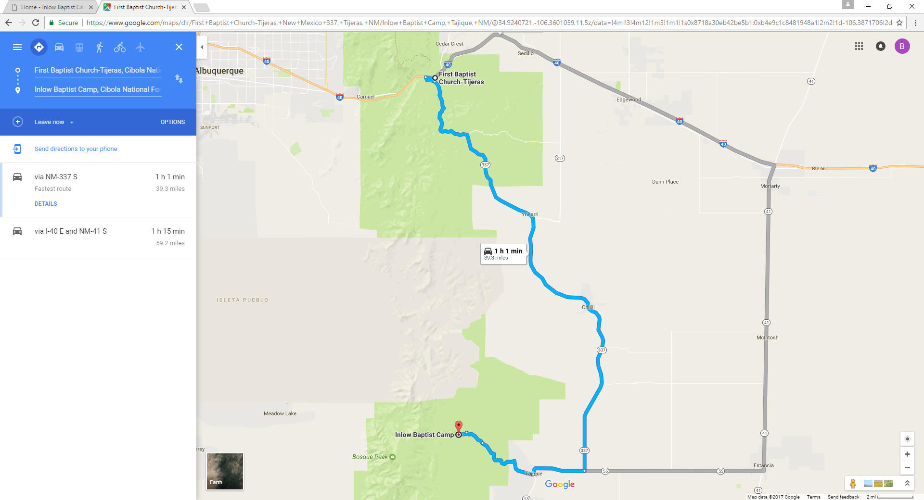
Take I-40 To Tijeras Exit.
At the stop light, go straight – headed south. First Baptist Church Tijeras will be on your left hand side. Head 30 miles south, the road will come to an intersection (55), make a right and head west 3 miles.
You will pass Ray’s store on your right, next door is a cemetery and a dirt road with a smoky the bear sign – make a right.
Head down the road 6 miles, you will see a sign for Inlow and 4th of July Campground on your right a few hundred feet before you’ll need to make a left turn to Inlow. Follow the road up to the camp.
There will be pink balloons marking the miles once you turn on the dirt road headed to Inlow.

